Name __________________________________ AP Calculus
Quick Review Sections 3.1 – 3.3

Show all your work!

1. Use the definition of the derivative to find the derivative of $f(x)=−2x^{2}−3$
at the point where x = 2.

- a. At which value of x is the function below not continuous?
b. At which value of x is the function below not differentiable?

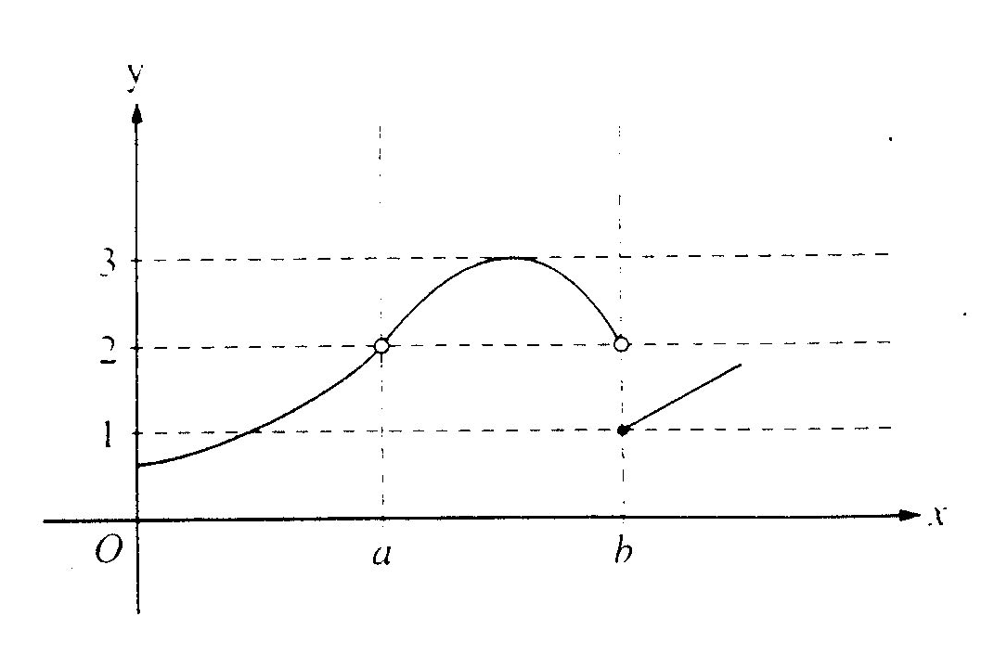
3.
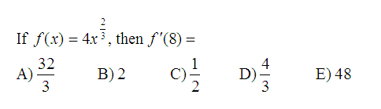

4. If $f(−3)=−\text{11}$ and $f'(−3)=2$, then write the equation of the tangent
to the curve $y=f(x)$ at x = –3.

5.

